IOT BASED SAFETY GADGET FOR CHILD SAFETY MONITORING AND NOTIFICATION

**M. Nandini Priyanka (2007)**

**Abstract:**

Child safety and tracking is a major concern as the more number of crimes on children are reported nowadays. With this motivation, a smart IoT device for child safety and tracking is developed to help the parents to locate and monitor their children. The system is developed using LinkIt ONE board programmed in embedded C and interfaced with temperature, heartbeat, touch sensors and also GPS, GSM & digital camera modules. The novelty of the work is that the system automatically alerts the parent/caretaker by sending SMS, when immediate attention is required for the child during emergency. The parameters such as touch, temperature &heartbeat of the child are used for parametric analysis and results are plotted for the same. The above system ensures the safety and tracking of children.

**S.Murugan(2009)**

**Abstract:**

Internet of Things (IoT) plays a major role in every day to day life. The major difference between IoT and embedded system is that a dedicated protocol/software is embedded in the chip in case of embedded system, whereas, IoT devices are smart devices, which are able to take decisions by sensing the environment around the device. The development of sensors technology, availability of internet connected devices; data analysis algorithms make IoT devices to act smart in emergency situations without human interventions. So, IoT devices are applied in different fields such as agriculture, medical, industrial, security and communication applications[1]. IoT systems are useful within a system to do deeper automation, analysis, and integration. IoT contributes to technology by advances in software, hardware and modern tools. It even uses existing and upcoming technology in the fields of sensing, networking and robotics. IoT brings global changes by its advanced elements in the social, economic, and political impact of the users.

**K N H Srinivas (2013)**

**Abstract:**

The review of literature for child safety and location tracking devices are discussed below. In [2], the parent can send a message to the GSM module, according to the message information the GSM module reply back with particular details of the children. The location can be seen on the Google map. When a particular child is facing an emergency situation, device button should be pressed so that the device captures the image along with the user information to the enrolled mobile numbers. The life of the child can be saved within no time. In [3], for the children point of view GPS, GPRS and GSM are used to monitor the speed and location tracking purpose. The system is fixed on the bus or car or in any vehicle so that the vehicle is going on routine route or not can be identified by the GPS tracker, the speed of the bus can also be extracted. Now-a-days the digital technology plays a major role for connecting persons via internet. For tracking the children, the android based solution is provided to parents. Internet is the one that will connects different components through a single device and is connected to server. Parents track their children in real time of the location tracker by GSM and [4] the microcontroller used is ARM-7 LPC2148. In day to day scenario, missing child cases are increasing gradually. Child caring is a major issue. Different types of methods are introduced to find good solutions. There have been many Methods and systems implemented to solve it. In [5],to solve child caring problem global position system (GPS) based solution with two nodes was proposed. In these two nodes, one node is child node which contains a Bluetooth module and a GPS receiver. The parent node consists of a mobile that supports Bluetooth. The location of thechild can be tracked by the GPS

technology and can be

displayed on the designed

**T D S Sarveswararao(2015)**

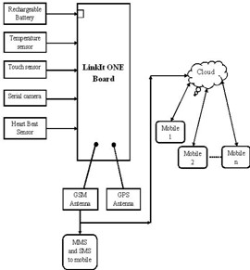**Abstract:**

## 

## Block diagram of IoT based Child safety

## The block diagram of the proposed child safety device is shown in Figure 1. The LinkIt ONE board is an open source platform. It consists of inbuilt Wi-Fi, GSM, GPS and Bluetooth modules. The link it one board is similar to the arduino board and it is termed as all-in-one prototyping board for wearable’s and IoT devices. The board consists of ARM7 EJ-S and the clock speed is 260MHz. A SIM and SD card slots are provided on the board itself. For the audio purpose a headset slot is also provided. The link it one is a robust development board for the hardware and also used for industrial applications. Different components such as Temperature sensor, Touch sensor, heartbeat sensor, GSM, GPS modules and serial camera are connected to the LinkIt ONE Board along with builtinGSM, GPS modules. Lithium ion battery is used as DC supply required to energize it. A rechargeable battery can also be used for the above purpose.

# **E Kusuma Kumari.(2017)**

**Abstract:**

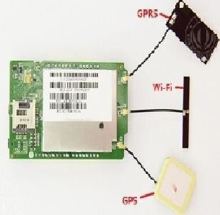

**LinkIt ONE board with inbuilt GPS, GPRS and**

The heartbeat sensor is used in the proposed system for measuring the pulse rate. There is a heartbeat pulse sensor which is combined to simple optical heart rate sensor with amplification and nullification circuitry making it is fast and easy to get reliable pulse reading. The GSM/GPRS block is activated with a SIM card on the board. GSM standard used here is GSM900. They mainly differ‘s based on bandwidth and RF carrier frequency. GSM network consists of mobile station, Base station subsystem network and operation subsystem. The GPS module is provided for identifying the location of the child. GPS module receives the signals from satellites which are located miles away. The latitude and longitude of the location can be identified by the GPS module. The Link it ONE board consists of micro SD/SIM combo. The device sends the monitored parameters data such as Temperature, touch and pulse rate to cloud. When there are any abnormalities in temperature or touch or pulse rate readings, a SMS is sent to the parent/caretaker mobile phone immediately.

After sending SMS the

serial camera captures the

Senthamilarasi.N(2018)

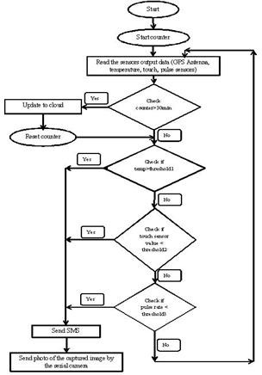**Abstract:**

Shows Flow chart of the proposed system. The counter should be started for counting time. The sensors output data should be read from the child safety device. The counter time should be checked for time interval of 30minutes. For every 30minutes except serial camera, the data from GPS, temperature, touch, pulse rate data is pushed into the cloud. The monitoring parameters are displayed on webpage. The counter is reset to restart the timer. So as to post the data into the cloud for every 30minutes. The sensors data is continuously read by the controller. When the value of temperature read from the sensor crosses the threshold1, notification messages are sent. The threshold value of the temperature is considered here is 38°C. Similarly, when the touch sensor value is crocess threshold2, notification messages are sent. Threshold of the touch sensor is considered here is 100. The Pulse rate intervel is analog value from the sensor, it is converted into the beats per minute (BPM) by formulae.

**K.Divyabharathi(2019)**

**Abstract:**

In the existing system, we use a voice recognition module in which the alert commands from the child are stored and kept for further reference. If the same child delivers the same command, it will compare with the alert command which was previously stored and sets an emergency level according to the alert command. The GSM has a SIM which is used to send an alert message or an alert call to the trusted peoples. GPS is used to track the live location and it is used when needed. The server will search the respective device ID from the database and search for respective contacts according to that device ID and helps in alerting the registered guardians

46.390C; it is above the threshold1

value i.e., 380C. Therefore, automatically an SMS alert is sent to the mobile and also an MMS is sent to parent mobile phonemodule which consists of an image indicating the surrounding area of the child

BPM = (1.0/Pulse Intervel) * 60.0 * 1000 Pulse rate in graph of adult person = 735

BPM = (1.0/735) * 60.0 * 1000 BPM **=** 81.63

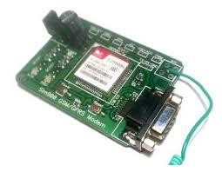

**M.Sangavi(2020)**

**Abstract:**

The figure4 shows touch sensor value in cloud. For every 30minutes the touch sensor value is stored in the cloud. In figure4 2PM to 3PM it shows that the value is below

100. Therefore, touch is not identified by the touch sensor,then automatically an SMS alert is sent to themobile and also an MMS is sent to mobile phonemodule which consists of an image indicating the surrounding area of the child. 3PM to 4PM in figure4 the touch sensor value is 925 that the body of the child is detected.

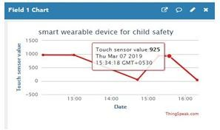

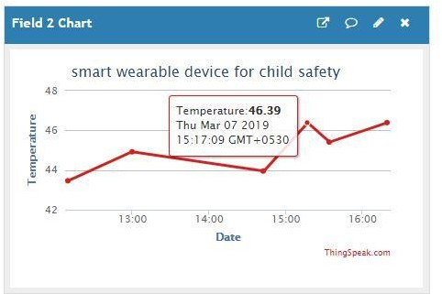

**P.Poonkuzhlai(2016)**

**Abstract:**

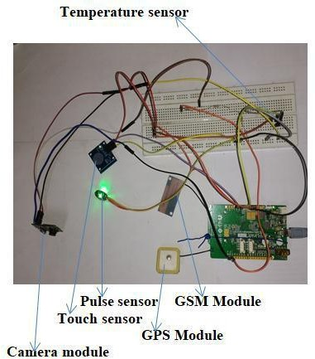

This research demonstrates Smart IoT device for child safety and tracking helping the parents to locate and monitor their children. If any abnormal values are read by the sensor then an SMS is sent to the parents mobile and an MMS indicating an image captured by the serial camera is also sent. The future scope of the work is to implement the IoT device which ensures the complete solution for child safety problems.

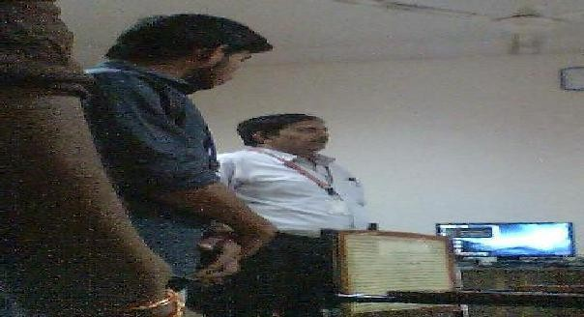

**K.Arthi(2014)**

**Abstract:**

This paper is mainly streamed towards child safety solutions by developing a gadget which can be tracked via its GPS locations and also a panic button on gadget is provided to alert the parent via GSM module calling for help. Parental android app is developed to manage and track the device anytime. Smart gadget device is always connected to parental phone which can receive and make phone calls and also receive SMS on gadget via GSM module, also a wireless technology is implemented on device which is useful to bound the device within a region of monitoring range, if device is moving out of monitoring range then an alert will be triggered on binding gadget, this helps you keep a virtual eye on child. Health monitoring system on gadget checking for parameters like heart beat/pulse rate and temperature is included which can be monitored on parental app. Gadget also monitors whether it is plugged on hand or not using contact switch and alert the parent as soon as it is unplugged

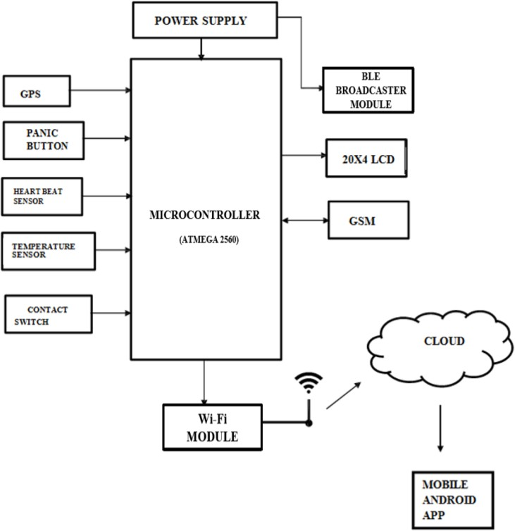

**V.M**.**Yaazhini(2006)**

**Abstract:**

The BLE Listener device is the device which is used to satisfy this feature along with safety gadget and parental phone. This gadget is also used to monitor safety gadget within a bounded area using wireless technology as follows, this feature of binding gadget is designed to work independently without phone network signal/internet so that safety gadget can even be under monitoring when it reaches remote areas where communication signals is not reachable like forest. Safety gadget consists of BEACON and BLE packet is transmitted through it, this packet is received by binding gadget which has BLE (Bluetooth Low Energy) receiver module, the packet usually contains information such as identification number, signal strength etc. Whenever the packet is received it checks for all the above information in the receiver device.

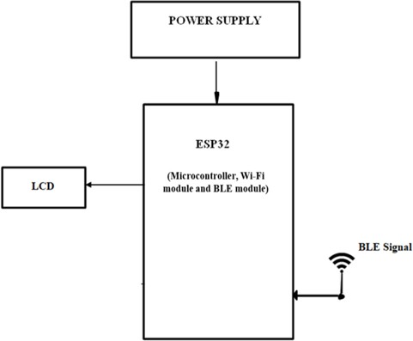

Tools Used

Hardware Requirements*:*

* + Arduino Mega [ATMEGA 2560].
  + GSM SIM 800C.
  + GPS Neo 6m.
  + 20X4 LCD.
  + I2C LCD Driver
  + 7805 Voltage Regulator.
  + Heart Beat Sensor.
  + DS18B20 Temperature Sensor.
  + 1x4 Switch.
  + ESP8266-12E
  + Push Button
  + Logic Level Convertor
  + Buzzer
  + LED
  + ESP32
  + OLED
  + Jumper Cables

*Software Requirements:*

* + Arduino IDE
  + Android Studio

*Languages Used:*

* + Embedded C
  + Java

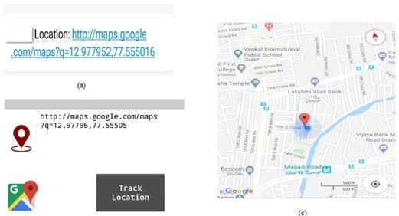

**N.Komal(2011)**

**Abstract**

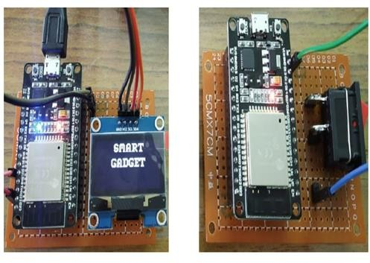

the circuit connection with sensors. The temperature sensor, pulse sensor, BLE module, GSM module and GPS module are shown.

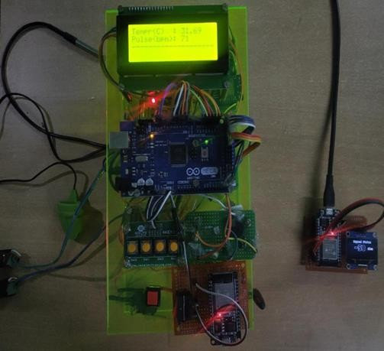

This is used to track the safety gadget using the binding gadget by implementing signal strength concept as soon as the safety gadget moves far away from the BLE listener gadget then an alert is provided to itself

# **CONCLUSION**

The word Future resembles the word Children. As Dr. A.P.J Abdul Kalam’s words “Youngsters are the future pillars of one’s nation", today's children are tomorrow's youngsters, preserving their dreams and life for a better future is necessary. Therefore, each and every parent should take care of their own children, without letting them to fall into the dark world of abusements, which entirely ruin them physically, mentally and emotionally destroying our future. Hence, considering the importance of our future, our project makes it easy for parents to track their children and to visually monitor them on regular basis, which makes them ensure the safety of their children and reduces the rate of incidents of child abuse.

# **REFERENCES**

[1] AkashMoodbidri, Hamid Shahnasser, ”Child Safety Wearable Device”, Department of Electrical and Computer Engineering San Francisco State University.

[2] AnandJatti, MadhviKannan , Alisha RM, Vijayalakshmi P, ShresthaSinha, " Design and Development of an IOT based wearable device forthe Safety and Security of women and girl children “, IEEE International Conference On Recent Trends In Electronics Information Communication Technology, May 20-21, 2016, India.

[3] Anwaar Al-Lawati, Shaikha Al-Jahdhami,

[4] " RFID-based System for School Children Transportation Safety Enhancement ", Proceedings of the 8th IEEE GCC Conference and Exhibition, Muscat, Oman, 1-4 February 2015.

[5] Dr. R. Kamalraj, ” A Hybrid Model on Child Security and Activities Monitoring System using IoT”, IEEE Xplore Compliant Part Number: CFP18N67-ART; ISBN:978-1-5386-2456-2.

[6] Pooja.K.Biradar1, Prof S.B.Jamge2,” An Innovative Monitoring Application for Child Safety”,

DOI:10.15680/IJIRSET.2015.0409093.

[7] Prof. Sunil K Punjabi, Prof. Suvarna Chaure, "Smart Intelligent System for Women and Child Security” Department of Computer Engineering SIES Graduate School of Technology Nerul, Navi Mumbai, India.

[8] Sarifah Putri Raflesia, Firdaus, Dinda Lestarini, “An Integrated Child Safety using Geo-fencing Information on Mobile Devices", INTERNATIONAL CONFERENCE ON ELECTRICAL ENGINEERING AND COMPUTER SCIENCE (ICECOS) 2018.

[9] Zejun Huang1, ZhigangGao,” An Mobile Safety Monitoring System for Children”, 2014 10th

International Conference on Mobile Ad-hoc and Sensor Networks.-